LAB 3
Index Scan in PostgreSQL

What is an Index?
An index in PostgreSQL is a data structure that improves the speed of data retrieval operations by allowing the database to locate rows quickly without scanning the entire table.
Example Scenario
user_id | name | email
1 | Alice | alice@example.com
2 | Bob | bob@example.com
... | ... | ...
1000000 | John | john@example.com

Query without Index
SELECT * FROM users WHERE email = 'alice@example.com';
Execution method: Sequential Scan
PostgreSQL checks each row one by one to find the matching email.
For large tables, this results in slow performance.

Creating an Index
CREATE INDEX idx_users_email ON users(email);
Query with Index
SELECT * FROM users WHERE email = 'alice@example.com';
Execution method: Index Scan
PostgreSQL searches the index to find the location of the required email value and then directly accesses the matching row in the table.
Index Scan using idx_users_email on users
(cost=0.28..8.30 rows=1)
- cost=0.28..8.30 → Estimated cost is low, showing efficient execution
- rows=1 → Only one row is expected to match

Types of Indexes in PostgreSQL

PostgreSQL supports various types of indexes for different use cases.

- B-TREE INDEX (Default)
B-tree is the default index type in PostgreSQL

CREATE INDEX idx_users_email ON users(email);

PostgreSQL creates a B-tree index automatically.

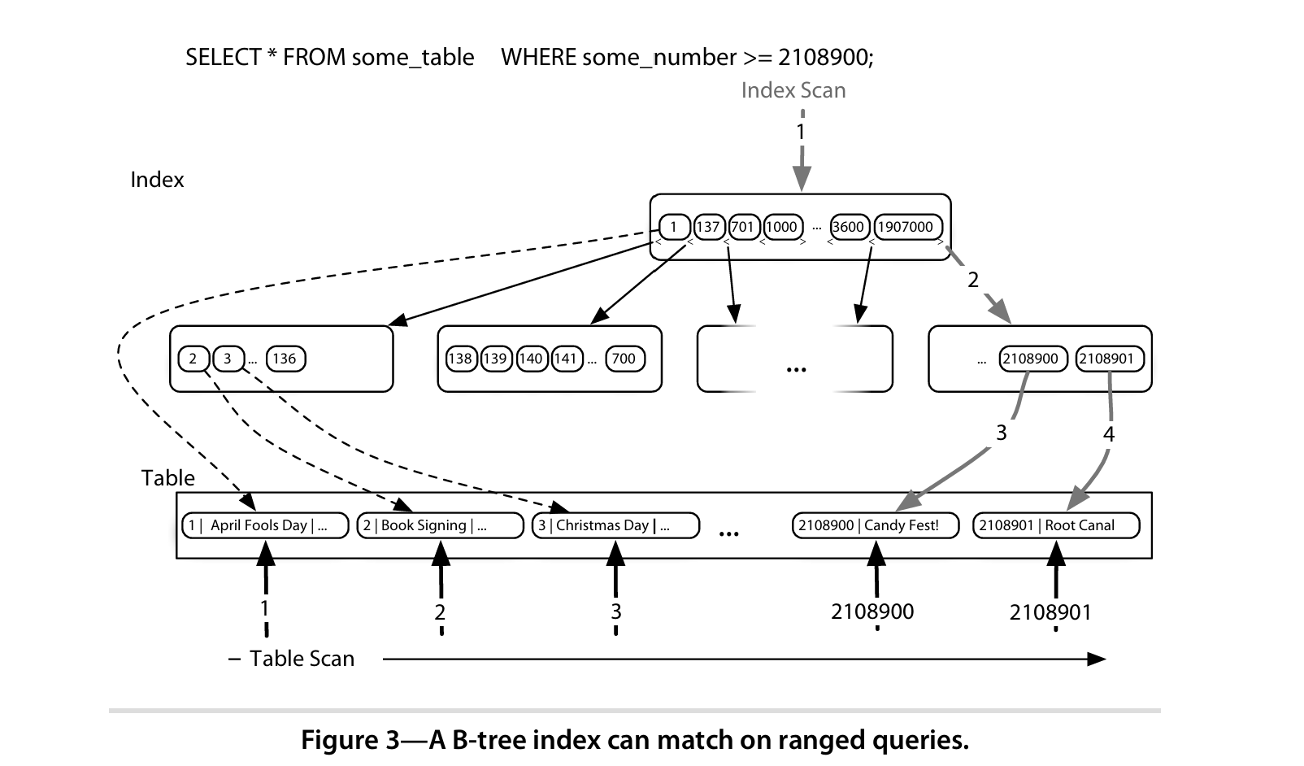
Execute query WITHOUT index
EXPLAIN ANALYZE
SELECT *
FROM Patients
WHERE DoctorID = 1;
Create B-Tree index
CREATE INDEX idx_patients_doctorid ON Patients(DoctorID);

Execute same query WITH index (default planner)
EXPLAIN ANALYZE
SELECT *
FROM Patients
WHERE DoctorID = 1;
Note: PostgreSQL uses a cost-based optimizer and may ignore the index if Seq Scan is cheaper.

Force index usage
SET enable_seqscan = OFF;

EXPLAIN ANALYZE
SELECT *
FROM Patients
WHERE DoctorID = 1;
Index Scan using idx_patients_doctorid
SET enable_seqscan = ON;

Note: DROP INDEX idx_patients_doctorid;
- Hash Index:
A hash index uses a hash function to map keys directly to buckets and is efficient for equality searches but does not support range queries.
CREATE INDEX idx_users_phone ON users USING hash(phone);
- PostgreSQL scans all rows of the table
- Takes the value of phone from each row
- Applies a hash function
- Stores hash value → row pointer in a bucket
- Data is not sorted, only bucketed
SELECT * FROM users WHERE phone = 9876;
users
id | name | phone
1 | asha | 9876
2 | ravi | 9123
3 | john | 9988
4 | meena | 9876

Hash function(phone) → Bucket
9123 → Bucket 2 → row 2
9988 → Bucket 7 → row 3
9876 → Bucket 5 → rows 1, 4

B-TREE INDEX(Example)

id | name | phone
1 | asha | 9876
2 | ravi | 9123
3 | john | 9988
4 | meena | 9876

CREATE INDEX idx_users_phone ON users(phone);
- Scans all rows of the table.
- Takes the value of phone from each row.
- Sorts the values.
- Builds a balanced tree structure (B-Tree).
- Stores key → row pointer in sorted order
Sorted phone values:
9123 → row 2
9876 → row 1
9876 → row 4
9988 → row 3
9876
/ \
9123 9988

SELECT * FROM users WHERE phone = 9988;
• Database starts at root of the tree
• Navigates left/right using comparisons
• Finds 9988
• Fetches row 3
SELECT * FROM users WHERE phone > 9500;
Database finds 9500
• Moves right in sorted order
• Returns: 9876 → row 1, row 4
9988 → row 3

Example table: users
id | name
1 | asha
2 | ravi
3 | asha
4 | john
5 | ravi
6 | asha

SELECT name, COUNT(*) AS cnt
FROM users
GROUP BY name;
- Table is scanned.
- Rows are grouped by name.
- Count is calculated for each group
- Rows are merged (collapsed)

name | cnt
asha | 3
ravi | 2
john | 1

Window Function
A window function in SQL performs a calculation across a set of table rows related to the current row, called a window.
Unlike aggregate functions used with GROUP BY, window functions do not collapse rows and return a result for each row.
Window functions are commonly used for ranking, running totals, moving averages, and analytical queries.
General Syntax of Window Function
window_function (expression)
OVER (
PARTITION BY column_name
ORDER BY column_name
)
- window_function:
Function applied on the window (e.g., ROW_NUMBER(), RANK(), DENSE_RANK(), SUM(), AVG(), COUNT())
- OVER():
Defines the window over which the function operates
- PARTITION BY (optional):
Divides rows into groups (like GROUP BY but without merging rows)
- ORDER BY (optional):
Specifies the order of rows within each partition
SELECT id, name,
COUNT(*) OVER (PARTITION BY name) AS cnt
FROM users;
Table is scanned
• Rows are partitioned by name
• Count is calculated per partition
• Each original row is preserved
id | name | cnt
1 | asha | 3
2 | ravi | 2
3 | asha | 3
4 | john | 1
5 | ravi | 2
6 | asha | 3

SELECT name,
COUNT(*) AS cnt,
RANK() OVER (ORDER BY COUNT(*) DESC) AS rank
FROM users
GROUP BY name;
name | cnt | rank
asha | 3 | 1
ravi | 2 | 2
john | 1 | 3

id | name | city | age
1 | asha | blr | 22
2 | ravi | blr | 25
3 | asha | mys | 24
4 | john | blr | 30
5 | ravi | mys | 23
6 | asha | blr | 21

1. Count users with same name, but show it for every row

SELECT id, name,
COUNT(*) OVER (PARTITION BY name) AS name_count
FROM users;
id | name | name_count
1 | asha | 3
3 | asha | 3
6 | asha | 3
2 | ravi | 2
5 | ravi | 2
4 | john | 1

2. Count users in each city, don’t remove rows

3. Give a unique number based on age order

SELECT id, name,
ROW_NUMBER() OVER (ORDER BY age) AS row_no
FROM users;
id | name | row_no
6 | asha | 1
1 | asha | 2
5 | ravi | 3
3 | asha | 4
2 | ravi | 5
4 | john | 6

4. For each city, number users by age
SELECT id, name, city,
ROW_NUMBER() OVER (
PARTITION BY city
ORDER BY age
) AS city_row_no
FROM users;
id | name | city | city_row_no
6 | asha | blr | 1
1 | asha | blr | 2
2 | ravi | blr | 3
4 | john | blr | 4
5 | ravi | mys | 1
3 | asha | mys | 2

5. Show average user age of the city on every row
SELECT id, name, city, age,
AVG(age) OVER (PARTITION BY city) AS avg_age_city
FROM users;
id | name | city | age | avg_age_city
1 | asha | blr | 22 | 24.5
2 | ravi | blr | 25 | 24.5
4 | john | blr | 30 | 24.5
6 | asha | blr | 21 | 24.5
3 | asha | mys | 24 | 23.5
5 | ravi | mys | 23 | 23.5

Difference between RANK() and DENSE_RANK()
Both functions assign ranks based on order, and same values get the same rank.

RANK()
- Same values → same rank
- Skips rank numbers after a tie (gap occurs)
- Used for competition ranking

DENSE_RANK()
- Same values → same rank
- No gaps in ranking numbers
- Used for class/academic ranking
Name | Marks
Asha | 90
Ravi | 80
John | 80
Meena | 70
Rank
Name | Rank
Asha | 1
Ravi | 2
John | 2
Meena | 4

Dense Rank
Name | Dense_Rank
Asha | 1
Ravi | 2
John | 2
Meena | 3
SELECT name, marks,
RANK() OVER (ORDER BY marks DESC) AS rank
FROM students;

SELECT name, marks,
DENSE_RANK() OVER (ORDER BY marks DESC) AS dense_rank
FROM students;

PostgreSQL Transactions – Explanation

What is a Transaction?
A transaction in PostgreSQL is a group of one or more SQL operations that are treated as one single unit of work.
Either all operations succeed or none of them are applied to the database.
This is important to maintain data consistency and correctness, especially when multiple changes are involved.

ACID Properties of Transactions
Transactions follow ACID properties:
- Atomicity
  - The transaction is all-or-nothing.
  - If one operation fails, everything is rolled back.
- Consistency
  - The database moves from one valid state to another valid state.
  - Rules like constraints, keys, and triggers are not violated.
- Isolation
  - Multiple transactions can run at the same time without affecting each other.
  - Intermediate (partial) results are not visible to other transactions.
- Durability
  - Once a transaction is committed, the changes are permanent, even if the system crashes.

2. How to Use Transactions in PostgreSQL
Transactions are controlled using:
- BEGIN or BEGIN TRANSACTION
- COMMIT
- ROLLBACK

Basic Syntax
BEGIN TRANSACTION;
-- SQL statements
COMMIT; -- Save changes
-- OR
ROLLBACK; -- Undo changes

Example: BEGIN, COMMIT, and ROLLBACK
BEGIN TRANSACTION;
DELETE FROM employees WHERE salary < 20000;
ROLLBACK;
SELECT * FROM employees;
🔹 Explanation:
- The DELETE removes records temporarily.
- ROLLBACK undoes the delete.
- The SELECT shows that no records were actually deleted.
This proves that changes are not permanent until COMMIT.

3. Real-World Example: Bank Transaction
In banking, money transfer must be safe.
BEGIN TRANSACTION;
UPDATE account SET balance = balance - 5000 WHERE account_id = 1001;
UPDATE account SET balance = balance + 5000 WHERE account_id = 2002;
COMMIT;
🔹 Explanation:
- ₹5000 is deducted from one account.
- The same amount is added to another account.
- COMMIT makes both changes permanent.
If the second update fails:
- The first update is not saved
- Money is not lost
This shows Atomicity and Consistency.

4. Implicit Transactions in PostgreSQL
- PostgreSQL automatically treats every SQL statement as a transaction.
- If a single command fails, PostgreSQL rolls back that command automatically.
Example:
DELETE FROM table_name WHERE condition;
If this fails, PostgreSQL undoes it automatically.
This is called an implicit transaction.

5. Handling Failures Using ROLLBACK
If something goes wrong during a transaction, we can manually undo everything.
BEGIN TRANSACTION;
UPDATE products SET stock = stock - 5 WHERE product_id = 101;
UPDATE orders SET status = 'Completed' WHERE order_id = 202;
ROLLBACK;
🔹 Explanation:
- Stock reduction and order update happen temporarily.
- ROLLBACK undoes both updates.
- No partial data is saved.
This prevents half-done operations.

6. SAVEPOINT (Nested Transactions)
PostgreSQL supports SAVEPOINT, which allows partial rollback.
BEGIN TRANSACTION;
UPDATE customers SET status = 'Gold' WHERE customer_id = 1;
SAVEPOINT save1;
UPDATE customers SET discount = 10 WHERE customer_id = 1;
ROLLBACK TO save1;
COMMIT;
🔹 Explanation:
- Status update is done.
- Savepoint is created.
- Discount update is rolled back.
- COMMIT saves only the status change.
Useful in complex transactions where only part needs undoing.

Function in PostgreSQL
A reusable block of SQL code that takes input, performs some logic, and returns a value (or table).
CREATE FUNCTION function_name(parameters)
RETURNS return_type
LANGUAGE plpgsql
AS $$
BEGIN
-- logic
RETURN value;
END;
$$;

Part | Meaning
CREATE FUNCTION | Create new function
parameters | Input values
RETURNS | What type it returns
LANGUAGE plpgsql | PostgreSQL programming language
BEGIN…END | Function body
RETURN | Sends result back

Example 1 – Simple Function

CREATE FUNCTION add_numbers(a INT, b INT)
RETURNS INT
LANGUAGE plpgsql
AS $$
BEGIN
RETURN a + b;
END;
$$;

// SELECT add_numbers(5,10);
Function Returning a Table
CREATE FUNCTION get_users_by_age(min_age INT)
RETURNS TABLE(id INT, name TEXT, age INT)
LANGUAGE plpgsql
AS $$
BEGIN
RETURN QUERY
SELECT * FROM users WHERE age >= min_age;
END;
$$;
SELECT * FROM get_users_by_age(30);
- Takes minimum age
- Returns all users >= that age
Function with IF-ELSE
CREATE FUNCTION check_even_odd(n INT)
RETURNS TEXT
LANGUAGE plpgsql
AS $$
BEGIN
IF n % 2 = 0 THEN
RETURN 'Even';
ELSE
RETURN 'Odd';
END IF;
END;
$$;

Function with OUT Parameter
CREATE FUNCTION get_balance(acc_id INT, OUT balance DECIMAL)
LANGUAGE plpgsql
AS $$
BEGIN
SELECT account_balance INTO balance
FROM accounts
WHERE id = acc_id;
END;
$$;

Benefits of Functions
Encapsulation: Reuse complex queries as a function.
Performance: Runs inside PostgreSQL, reducing client-server interaction.
Security: Can restrict direct table access and return controlled data.

Note:
CREATE FUNCTION get_rich_accounts()
RETURNS TABLE(id INT, name TEXT, age INT, balance DECIMAL)
LANGUAGE plpgsql
AS $$
BEGIN
RETURN QUERY
SELECT * FROM accounts
WHERE balance > (SELECT AVG(balance) FROM accounts);
END;
$$;

Stored Procedure
A set of SQL statements stored in the database that can be executed using CALL.

Function | Procedure
Must return value | Does not need to return
Called using SELECT | Called using CALL
Cannot use COMMIT/ROLLBACK | Can use COMMIT/ROLLBACK

Simple Procedure Example
CREATE PROCEDURE add_user (IN username TEXT, IN user_age INT)
LANGUAGE plpgsql
AS $$
BEGIN
INSERT INTO users (name, age)
VALUES (username, user_age);
END;
$$;
Call it:
CALL add_user('John Doe', 30);

Transaction Inside Procedure
CREATE PROCEDURE transfer_funds(
IN sender_id INT,
IN receiver_id INT,
IN amount DECIMAL
)
LANGUAGE plpgsql
AS $$
BEGIN
BEGIN;
UPDATE accounts
SET balance = balance - amount
WHERE id = sender_id;

UPDATE accounts
SET balance = balance + amount
WHERE id = receiver_id;
COMMIT;
END;
$$;

CALL transfer_funds(1, 2, 500);

